Abstract
The Real Estate Booking System is a web-based application developed using MERN Stack technologies. The project helps users view and add property details such as house name, location, price, and images through an easy interface. It simplifies property management and booking processes by providing a digital platform for buyers and sellers. The system improves accessibility, reduces manual work, and provides a user-friendly experience.
Problem Statement
Traditional property management systems are mostly manual and time-consuming. Customers face difficulty in searching for suitable properties, and property owners find it difficult to manage listings efficiently. There is a need for a simple digital system that allows easy property viewing and management in one platform.
Objectives
- To develop a user-friendly real estate web application.
- To allow users to add and view property details.
- To reduce manual property management work.
- To provide quick access to property information.
- To improve efficiency in property booking systems.
Instructions to Run the Project
- Software Required
- Node.js
- Visual Studio Code
Steps
- Open project folder in VS Code.
- Open terminal.
- Install packages:
- Bash
- npm install express cors
- Run backend:
- Bash
- node server.js
- Open index.html in browser.
- Enter property details.
- Click “Add Property”.
Working Process
- User opens the application.
- User enters property title, location, price, and image URL.
- Frontend sends data to backend server.
- Server stores property data temporarily.
- Added properties are displayed on the webpage dynamically.
Applications
- Real estate property management
- House and apartment listing systems
- Property booking platforms
- Online property showcase systems
- Real estate agency management
Technologies Used
- HTML
- CSS
- JavaScript
- Node.js
- Express.

CODE:
Server.js
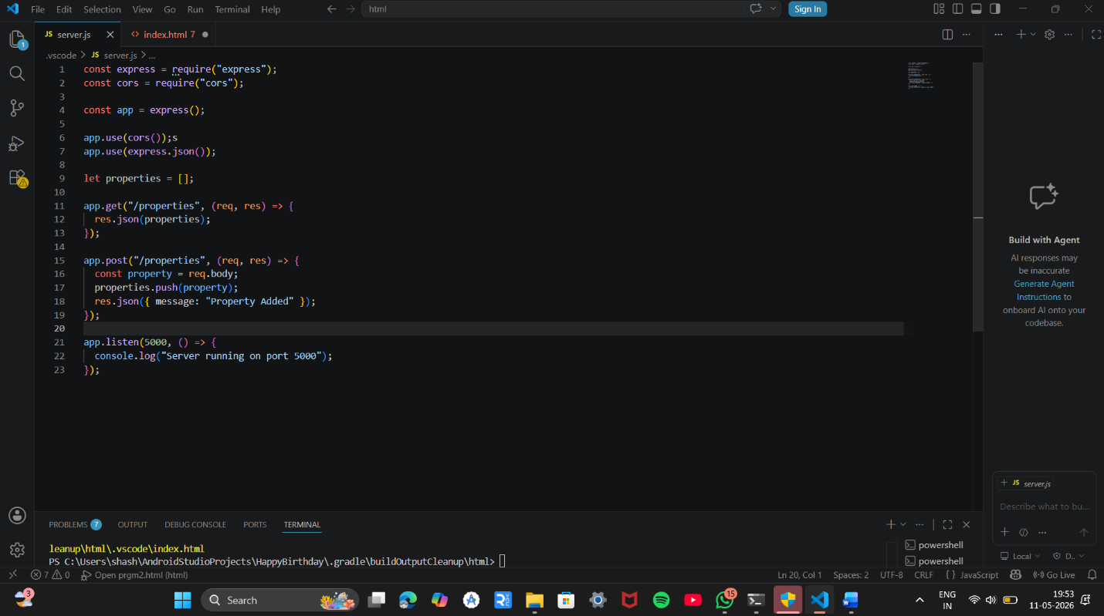
Index.html
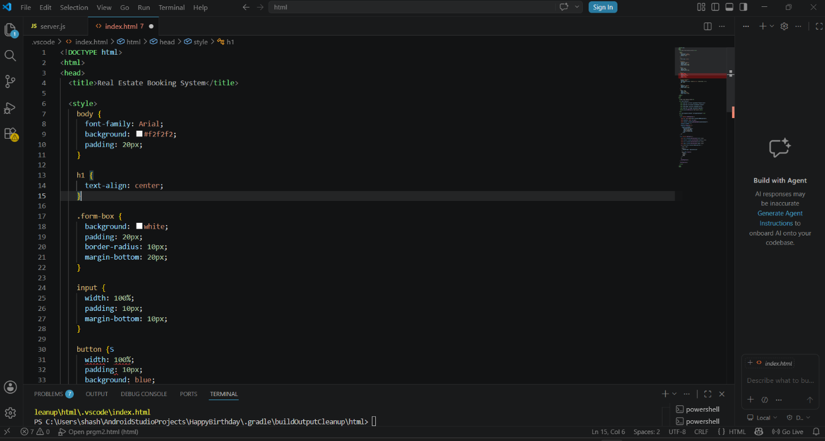

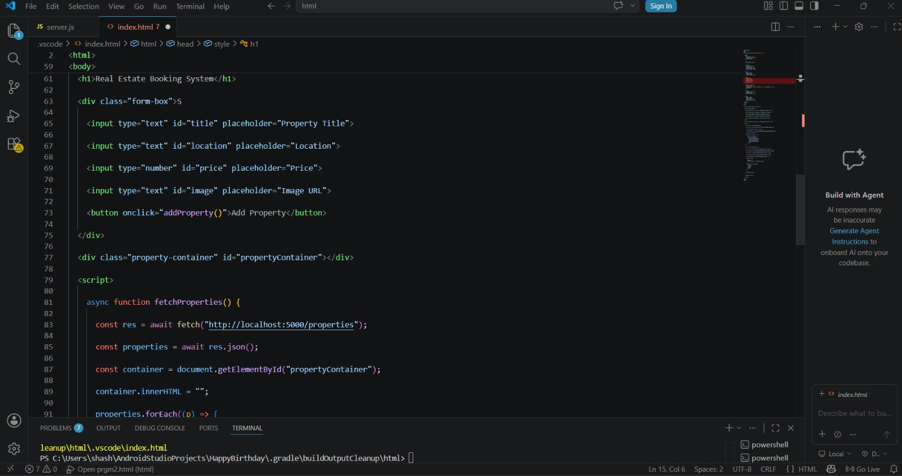

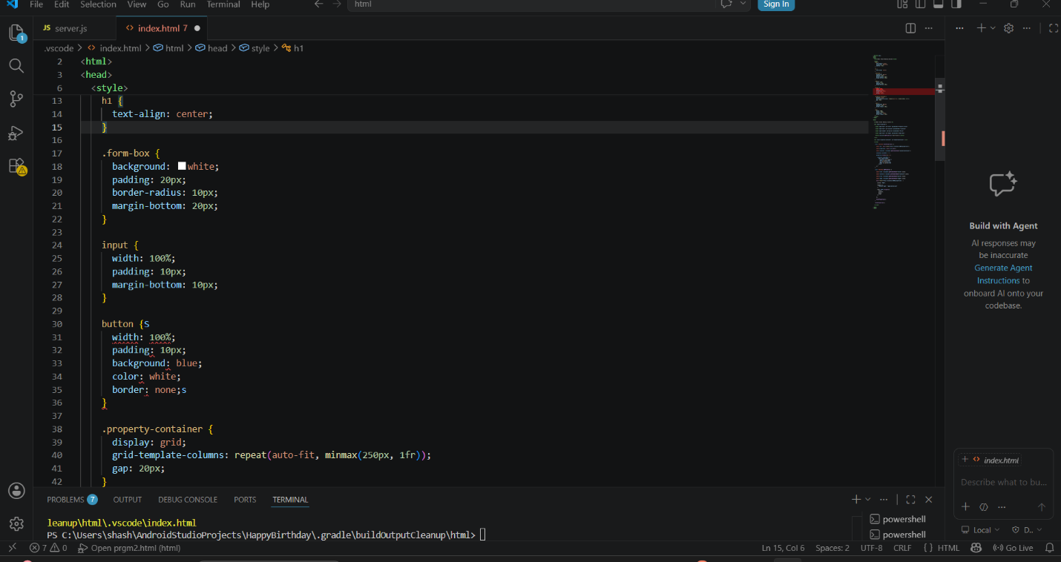

OUTPUT:
